**SPARK PROGRAMS**

**1.Write a spark to analyze the given weather report data and to generate a report with cities having maximum temperature for a particular year**

import sys

if(len(sys.argv)!=3):

print("Provide Input File and Output Directory")

sys.exit(0)

from pyspark import SparkContext

sc =SparkContext()

f = sc.textFile(sys.argv[1])

temp=f.map(lambda x: (int(x[15:19]),int(x[87:92])))

maxi=temp.reduceByKey(lambda a,b:a if a>b else b)

maxi.saveAsTextFile(sys.argv[2])

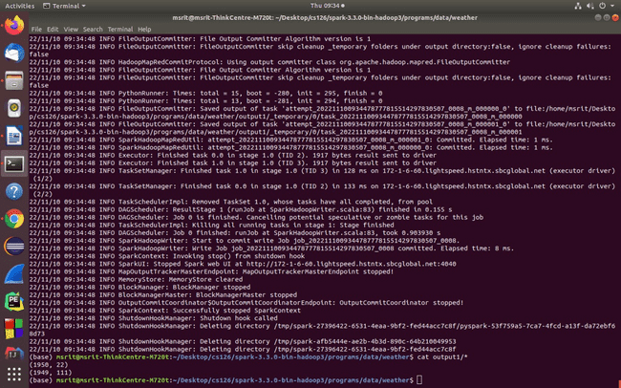

**2.Write a spark to analyze the given weather report data and to generate a report with cities having minimum temperature for a particular year**

import sys

if(len(sys.argv)!=3):

print("Provide Input File and Output Directory")

sys.exit(0)

from pyspark import SparkContext

sc =SparkContext()

f = sc.textFile(sys.argv[1])

temp=f.map(lambda x: (int(x[15:19]),int(x[87:92])))

mini=temp.reduceByKey(lambda a,b:a if a<b else b)

mini.saveAsTextFile(sys.argv[2])

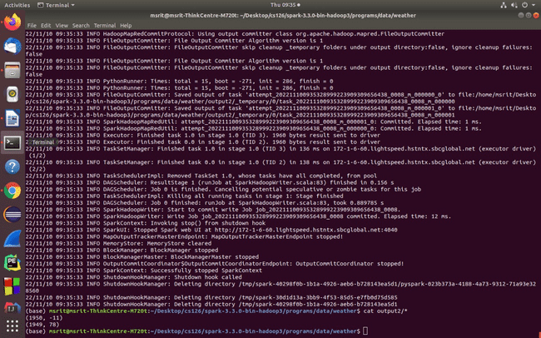

**3.Write a spark program to analyze the given Earthquake data and generate statistics with region and magnitude**

import sys

if(len(sys.argv)!=3):

print("Provide Input File and Output Directory")

sys.exit(0)

from pyspark import SparkContext

sc =SparkContext()

f = sc.textFile(sys.argv[1])

temp=f.map(lambda x: (x.split(',')[11],float(x.split(',')[8])))

maxi=temp.reduceByKey(lambda a,b:a if a>b else b)

maxi.saveAsTextFile(sys.argv[2])

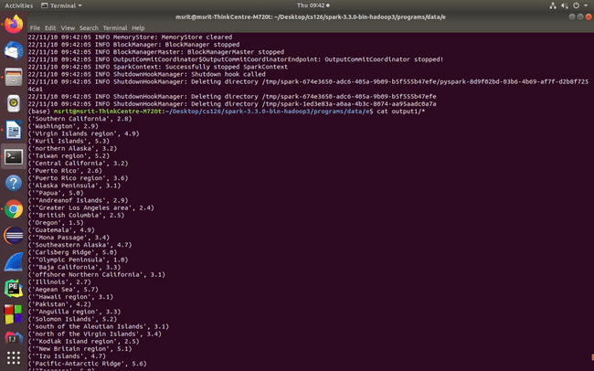

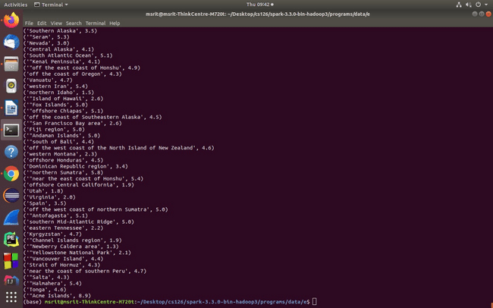

**4.Write a spark program to analyze the given Earthquake data and generate statistics with region and depth**

import sys

if(len(sys.argv)!=3):

print("Provide Input File and Output Directory")

sys.exit(0)from pyspark import SparkContext

sc =SparkContext()

f = sc.textFile(sys.argv[1])

temp=f.map(lambda x: (x.split(',')[11],float(x.split(',')[9])))

maxi=temp.reduceByKey(lambda a,b:a if a>b else b)

maxi.saveAsTextFile(sys.argv[2])

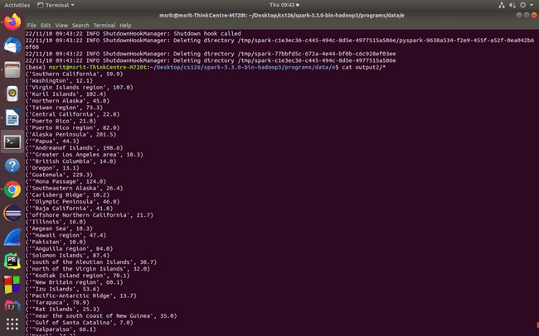

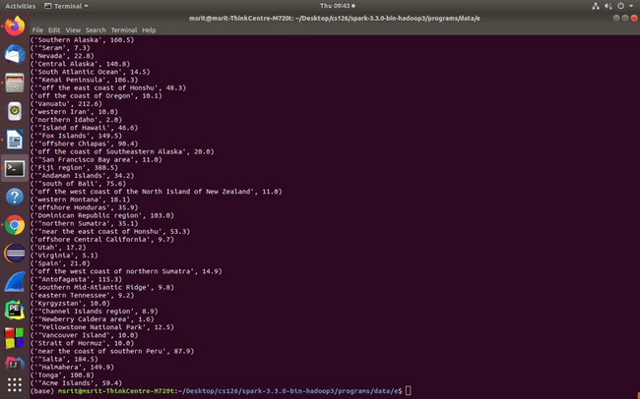

**5.Write a spark program to analyze the given Earthquake data and generate statistics with region and latitude**

import sys

if(len(sys.argv)!=3):

print("Provide Input File and Output Directory")

sys.exit(0)

from pyspark import SparkContext

sc =SparkContext()

f = sc.textFile(sys.argv[1])

temp=f.map(lambda x: (x.split(',')[11],float(x.split(',')[6])))

maxi=temp.reduceByKey(lambda a,b:a if a>b else b)

maxi.saveAsTextFile(sys.argv[2])

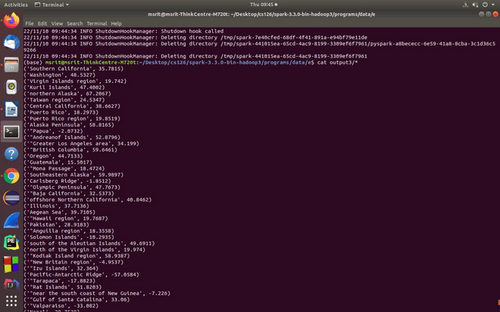

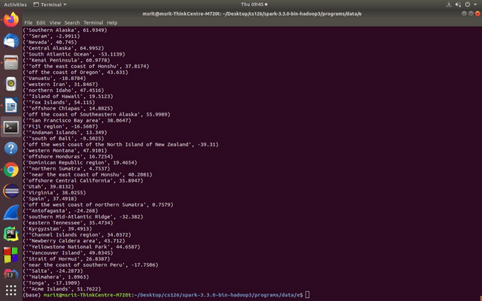

**6.Write a spark program to analyze the given Earthquake data and generate statistics with region and longitude**

import sys

if(len(sys.argv)!=3):

print("Provide Input File and Output Directory")

sys.exit(0)

from pyspark import SparkContext

sc =SparkContext()

f = sc.textFile(sys.argv[1])

temp=f.map(lambda x: (x.split(',')[11],float(x.split(',')[7])))

maxi=temp.reduceByKey(lambda a,b:a if a>b else b)

maxi.saveAsTextFile(sys.argv[2])

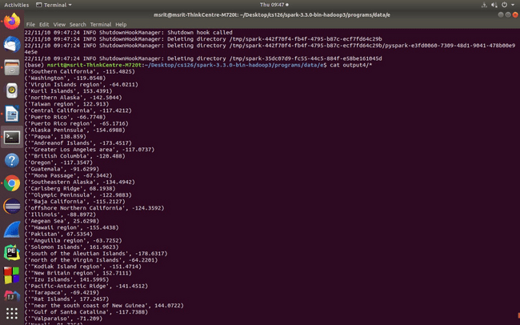

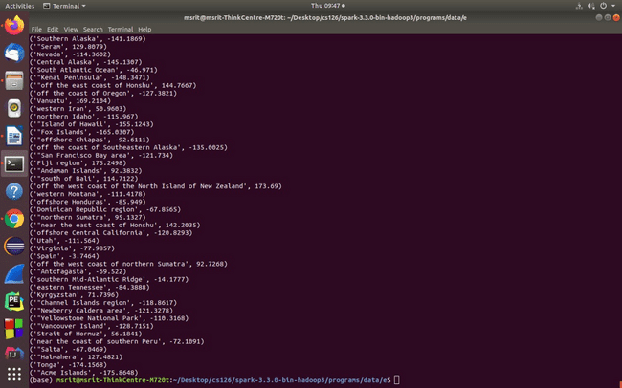

**7.Write a spark program to analyze the given Insurance data and generate a statistics report with the construction building name and the count of building.**

import sys

if(len(sys.argv)!=3):

print("Provide Input File and Output Directory")

sys.exit(0)

from pyspark import SparkContext

sc =SparkContext()

f = sc.textFile(sys.argv[1])

temp=f.map(lambda x: (x.split(',')[16],1))

data=temp.countByKey()

dd=sc.parallelize(data.items())

dd.saveAsTextFile(sys.argv[2])

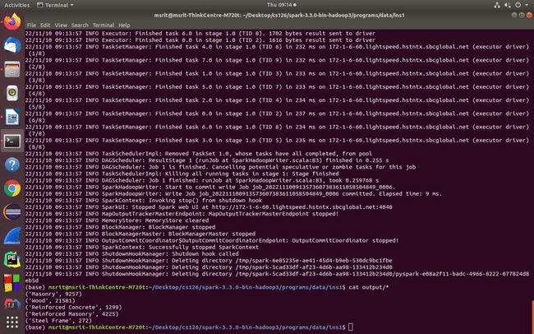

**8.Write a spark program to analyze the given Insurance data and generate a statistics report with the county name and its frequency.**

import sys

if(len(sys.argv)!=3):

print("Provide Input File and Output Directory")

sys.exit(0)

from pyspark import SparkContext

sc =SparkContext()

f = sc.textFile(sys.argv[1])

temp=f.map(lambda x: (x.split(',')[2],1))

data=temp.countByKey()

dd=sc.parallelize(data.items())

dd.saveAsTextFile(sys.argv[2])

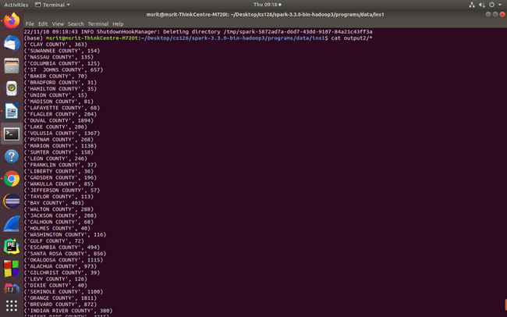

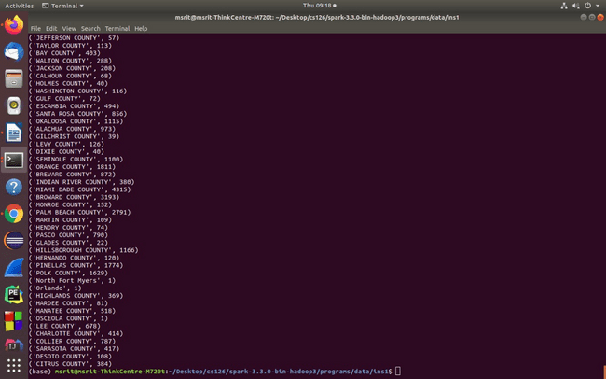

**9.Write a map-reduce program to analyze the given employee record data and generate a statistics report with the total Sales for female and male employees**

import sys

if(len(sys.argv)!=3):

print("Provide Input File and Output Directory")

sys.exit(0)

from pyspark import SparkContext

sc =SparkContext()

f = sc.textFile(sys.argv[1])

temp=f.map(lambda x: (x.split('\t')[3],float(x.split('\t')[8])))

total=temp.reduceByKey(lambda a,b : a+b)

total.saveAsTextFile(sys.argv[2])

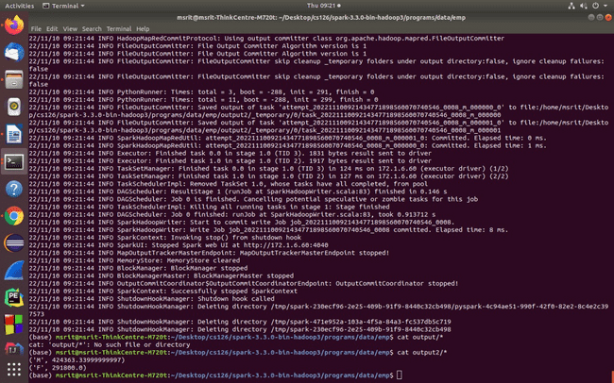

**10. Write a map-reduce program to analyze the given sales records over a period and generate data about the country’s total sales, and the total number of the products**

import sys

if(len(sys.argv)!=3):

print("Provide Input File and Output Directory")

sys.exit(0)

from pyspark import SparkContext

sc =SparkContext()

f = sc.textFile(sys.argv[1])

temp=f.map(lambda x: (x.split(',')[7],1))

data=temp.countByKey()

dd=sc.parallelize(data.items())

dd.saveAsTextFile(sys.argv[2])

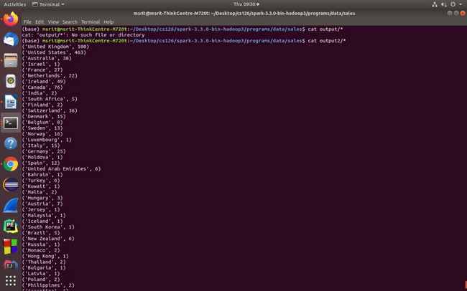

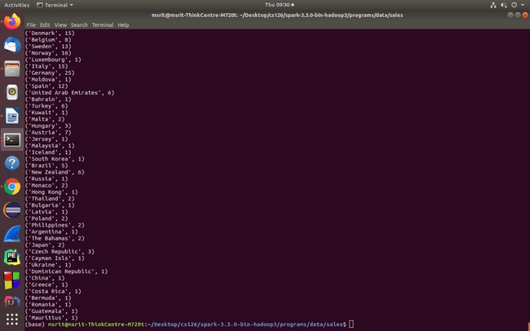

**11.Write a map-reduce program to analyze the given sales records over a period of time and generate data about the country’s total sales and the frequency of the payment mode.**

import sys

if(len(sys.argv)!=3):

print("Provide Input File and Output Directory")

sys.exit(0)

from pyspark import SparkContext

sc =SparkContext()

f = sc.textFile(sys.argv[1])

temp=f.map(lambda x: (x.split(',')[3],1))

data=temp.countByKey()

dd=sc.parallelize(data.items())

dd.saveAsTextFile(sys.argv[2])

